Key Insights and Trends—Pizza Sales
PIZZA SALES KPIs
1. Total Revenue:
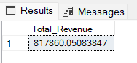
2. Average Order Value
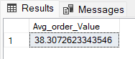
3. Total Pizzas Sold
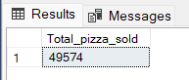
4. Total Orders
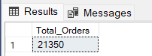
5. Average Pizzas Per Order
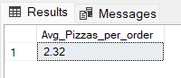

Daily Trend for Total Orders
Output:
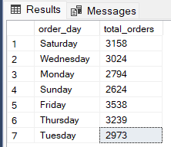
Insights: ORDERS ARE HIGHEST ON FRIDAY and LOWEST ON SUNDAY.
Monthly Trend for Orders
Output
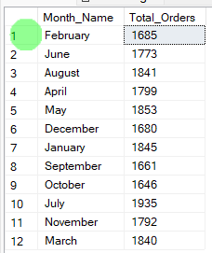
Insights: ORDERS ARE HIGHEST IN MONTH OF JULY AND LOWEST ON OCTOBER.

% of Sales by Pizza Category
Output
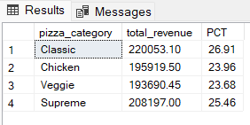
Insights: Classic Category contributes to Maximum Sales .

E. % of Sales by Pizza Size
Output
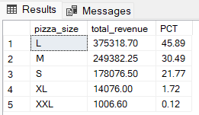
Insights: Large Pizza Size contributes to Maximum Sales.

F. Total Pizzas Sold by Pizza Category
Output
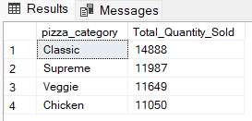
Insights: Classic Category contributes to Maximum total orders
G. Top 5 Pizzas by Revenue
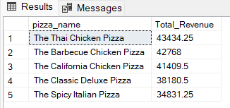
Insights: The Thai Chicken Pizza contributes to Maximum Revenue

H. Bottom 5 Pizzas by Revenue
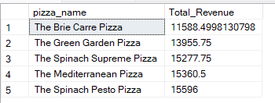
Insights: The Brie Carre Pizza contributes to minimum revenue.
I. Top 5 Pizzas by Quantity
Output
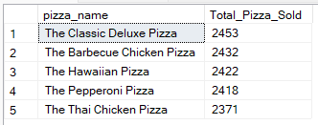
Insights: The Classic Deluxe Pizza contributes to Maximum quantities sold.

J. Bottom 5 Pizzas by Quantity
Output
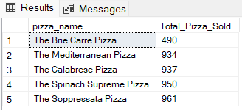
Insights: The Brie Carre Pizza contributes to Minimum quantities sold.

K. Top 5 Pizzas by Total Orders
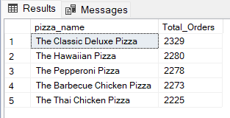
Insights: The Classic Deluxe Pizza contributes to maximum orders.

L. Bottom 5 Pizzas by Total Orders
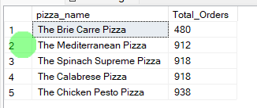
Insights: The Brie Carre Pizza contributes to minimum orders.

